## 

**SALES 2**

KPI obligatoires 2

● KP1 : Quantité par catégorie de produit (sur toutes les années) 2

● KP2 : COMMANDES PAS PAYÉes 3

KPI ADDITIONNELS 4

**FINANCE 4**

Codes en vrac 4

Panier moyen par Client 5

KPI obligatoires 5

● KPI CA / PAYS / 2 LAST MONTHS 5

KPI ADDITIONNELS 6

**LOGIST 6**

Codes en vrac 6

KPI obligatoires 6

● KPI STOCK 5 BEST CAPRODUCT: 6

KPI ADDITIONNELS 6

**RESS HUM 7**

KPI obligatoires 7

● 2 BEST EMPLOYEE / MOIS ⇒ KPI FINAL ? 7

KPI ADDITIONNELS 8

## 

## 

## 

## 

## SALES

### **KPI obligatoires**

#### KP1 : Quantité par catégorie de produit (sur toutes les années)

**SELECT**

*p2*.productLine **AS** *Categorie*,

**MONTH**(*o*.orderDate) **AS** *mois*,

**YEAR**(*o*.orderDate) **AS** *annee*,

**COUNT**(*o*.orderNumber) **AS** *Sales*,

**LAG**(**COUNT**(*o*.orderNumber)) **OVER** (**PARTITION** **BY** *p2*.productLine, **month**(*o*.orderDate) **ORDER** **BY** *o*.orderDate) **AS** *Sales_Previous_Year*,

**COUNT**(*o*.orderNumber) - **LAG**(**COUNT**(*o*.orderNumber)) **OVER** (**PARTITION** **BY** *p2*.productLine, **month**(*o*.orderDate) **ORDER** **BY** *o*.orderDate) **AS** *Taux_variation*

**FROM**

orders *o*

**JOIN**

customers *c* **ON** *c*.customerNumber = *o*.customerNumber

**JOIN**

orderdetails *o2* **ON** *o*.orderNumber = *o2*.orderNumber

**JOIN**

products *p* **ON** *p*.productCode = *o2*.productCode

**JOIN**

productlines *p2* **ON** *p2*.productLine = *p*.productLine

**WHERE**

**YEAR**(*o*.orderDate) **IN** (**YEAR**(**CURRENT_DATE**), **YEAR**(**CURRENT_DATE**) - 1, **YEAR**(**CURRENT_DATE**) - 2)

**GROUP** **BY**

*Categorie*,

*mois*,

*annee*

**ORDER** **BY**

*Categorie*,

*annee*,

*mois*;

#### KP2 : COMMANDES PAS PAYÉes

WITH orderbycustom AS (

SELECT SUM(quantityordered*priceeach) as CA_order, os.customerNumber

FROM orderdetails as o

INNER JOIN orders AS os ON os.orderNumber = o.orderNumber

WHERE os.status != "Cancelled"

GROUP BY os.customerNumber

)

SELECT oc.customerNumber,

oc.CA_order - SUM(p.amount) as Reste_dû,

c.creditlimit as Crédit_max,

oc.CA_order - SUM(p.amount) > c.creditlimit as sup_crédit_max,

ROUND(((oc.CA_order - SUM(p.amount)) / c.creditlimit) * 100,2) as crédit_autorisé_percent

FROM orderbycustom as oc

INNER JOIN payments AS p ON oc.customerNumber = p.customerNumber

INNER JOIN customers AS c on c.customerNumber = oc.customerNumber

GROUP BY p.customernumber

HAVING Reste_dû != 0

ORDER BY crédit_autorisé_percent DESC;

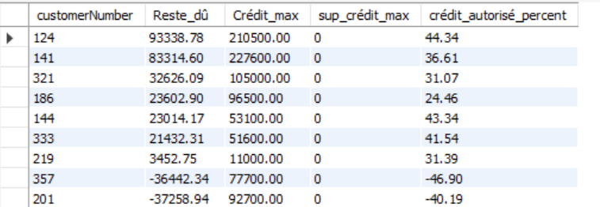

**⇒ mieux, prends en compte les commandes annulées**

* **ce qu’on doit à des clients (suite à commandes annulées après paiement)**

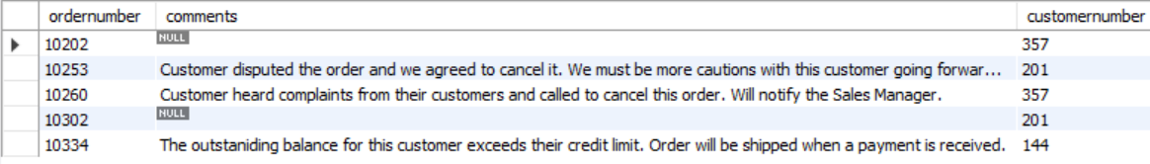

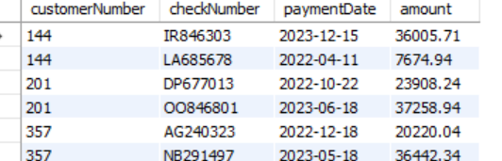

⇒ précisions sur les nbr négatifs précédent

* PAR COMMANDES IMPAYÉES - 1 PB avec le 144 qui ne s'affiche pas

SELECT o.orderNumber, SUM(od.quantityordered*od.priceeach) as Tot_order, o.customerNumber

FROM orders AS o

INNER JOIN orderdetails as od on od.ordernumber = o.ordernumber

LEFT JOIN payments AS p ON o.customerNumber = p.customerNumber

AND o.orderDate <= p.paymentDate

WHERE p.customerNumber IS NULL AND o.status != "Cancelled"

GROUP BY o.orderNumber

ORDER BY o.customernumber, o.orderNumber;

### KPI ADDITIONNELS

## FINANCE

### **Codes en vrac**

* **CA par orderNumber des 2 derniers mois**

SELECT o.orderNumber, SUM(quantityordered*priceeach) as CA_order, os.orderDate, os.customerNumber, os.status

FROM orderdetails as o

INNER JOIN orders AS os ON os.orderNumber = o.orderNumber

GROUP BY o.ordernumber

HAVING os.orderDate BETWEEN '2023-12-20' AND '2024-02-20'

AND os.status != "Cancelled";

* Les commandes CANCELLED

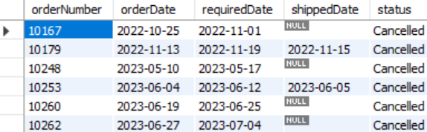

### **Panier moyen par Client**

select

customers.customerName,orderdetails.orderNumber,

AVG(orderdetails.quantityOrdered) as Panier_moyen

from

customers

join

orders on customers.customerNumber = orders.customerNumber

join

orderdetails on orderdetails.orderNumber = orders.orderNumber

group by

customerName

order by

customerName

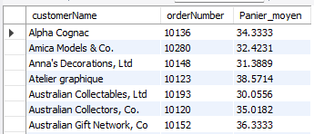

### **KPI obligatoires**

#### KPI CA / PAYS / 2 LAST MONTHS

WITH CAorder AS (

SELECT o.orderNumber, SUM(quantityordered*priceeach) as CA_order, os.orderDate, os.customerNumber, os.status

FROM orderdetails as o

INNER JOIN orders AS os ON os.orderNumber = o.orderNumber

GROUP BY o.ordernumber

HAVING os.orderDate >= (SELECT DATE_SUB(MAX(orderDate), INTERVAL 2 MONTH) FROM orders)

AND os.status != "Cancelled"

)

SELECT c.country, SUM(CA_order) AS CA_Pays

FROM CAorder as ca

JOIN customers AS c ON c.customerNumber = ca.customerNumber

GROUP BY c.country

ORDER BY CA_Pays DESC;

### KPI ADDITIONNELS

## LOGIST

### **Codes en vrac**

### **KPI obligatoires**

#### KPI STOCK 5 BEST CAPRODUCT:

**SELECT** products.productName **AS** *Nom_Produit* , quantityInStock **AS** *Stock*

**FROM**(

**SELECT** *od*.productCode, **sum**(*od*.quantityOrdered) **AS** *Somme_Quantity*

**FROM** orderdetails *od*

**JOIN** products *p* **ON** *p*.productCode = *od*.productCode

**GROUP** **BY** *p*.productCode

**ORDER** **BY** *Somme_Quantity* **DESC**

**LIMIT** 5

) **AS** *TopProduct*

**JOIN** products **ON** products.productCode = *TopProduct*.productCode;

### KPI ADDITIONNELS

## RESS HUM

### **KPI obligatoires**

#### 2 BEST EMPLOYEE / MOIS ⇒ KPI FINAL ?

WITH CA_par_clients AS (

SELECT

SUM(od.quantityordered * od.priceeach) AS CA_order,

o.customerNumber,

c.salesRepEmployeeNumber,

EXTRACT(YEAR FROM o.orderDate) AS orderYear,

EXTRACT(MONTH FROM o.orderDate) AS orderMonth

FROM

orders AS o

INNER JOIN

orderdetails AS od ON o.orderNumber = od.orderNumber

INNER JOIN

customers AS c ON c.customerNumber = o.customerNumber

GROUP BY

o.customerNumber, c.salesRepEmployeeNumber, orderYear, orderMonth

),

CA_par_employe AS (

SELECT

CA.salesRepEmployeeNumber,

CA.orderYear,

CA.orderMonth,

SUM(CA.CA_order) AS CA_per_Employee,

ROW_NUMBER() OVER (PARTITION BY CA.orderYear, CA.orderMonth ORDER BY SUM(CA.CA_order) DESC) AS monthly_position

FROM

CA_par_clients AS CA

GROUP BY

CA.salesRepEmployeeNumber, CA.orderYear, CA.orderMonth

)

SELECT

e.lastname,

e.firstname,

orderYear,

orderMonth,

CA_per_Employee,

monthly_position

FROM

CA_par_employe

INNER JOIN

employees AS e ON e.employeeNumber = salesRepEmployeeNumber

WHERE

monthly_position <= 2

ORDER BY

orderYear, orderMonth, CA_per_Employee DESC;

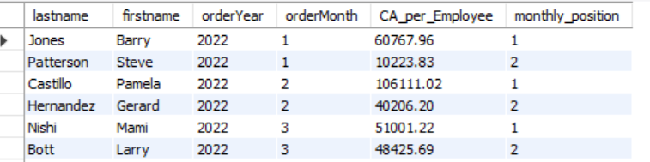

### KPI ADDITIONNELS